**PROJECT BASED LAB REPORT**

**On**

***Dental Clinic Website***

**By**

***Jaynica Nunna - AP19110010078***

***Prattipati Manoj Sai – AP19110010109***

***Ennamuri Venkata Pavan Kumar – AP19110010107***

|  |  |
| --- | --- |
|  | **SRM UNIVERSITY AP ANDHRA PRADESH**  **DEPARTMENT OF COMPUTER SCIENCE AND ENGINEERING** |
|  |  |

***CERTIFICATE***

This is to certify that this project based lab report entitled **“*Dental Clinic Website* ”** is a bonafide work done by Jaynica.N(AP19110010078),Manoj Sai Prattipati(AP19110010109),Venkata Pavan Kumar Ennamuri(AP19110010107) in partial fulfillment of the requirement for the

award of degree in **BACHELOR OF TECHNOLOGY** in **Computer Science and**

**Engineering** during the academic year 2020-2021.

**Faculty In Charge Head of the Department SRM UNIVERSITY AP ANDHRA PRADESH**

**DEPARTMENT OF COMPUTER SCIENCE AND ENGINEERING**



***DECLARATION***

We hereby declare that this project based lab report entitled **“Dental Clinic Website”** has been prepared by us in partial fulfillment of the requirement for the award of degree “**BACHELOR OF TECHNOLOGY in COMPUTER** **SCIENCE AND ENGINEERING**” during the academic year 2020-2021.

I also declare that this project based lab report is of our own effort and it has not been submitted to any other university for the award of any degree.

NAME: REG NO:-

N.JAYNICA AP19110010078

P.MANOJ SAI AP19110010109

E.VENKATA

PAVAN KUMAR AP19110010107

**Date:**

**Place:**

**ACKNOWLEDGEMENTS**

My sincere thanks to SANJEEV KUMAR in the Lab for their outstanding support throughout the project for the successful completion of the work

We express our gratitude to **Dr.T. RAGUNATHAN ,** Head of the Department for Computer Science and Engineering for providing us with adequate facilities, ways and means by which we are able to complete this term paper work.

We would like to place on record the deep sense of gratitude to the honourable Vice Chancellor, SRM University AP ANDHRA PRADESH for providing the necessary facilities to carry the concluded term paper work.

Last but not the least, we thank all Teaching and Non-Teaching Staff of our department and especially my classmates and my friends for their support in the completion of our term paper work.

N.JAYNICA(AP19110010078)

P.MANOJ SAI(AP19110010109)

E.VENKATA PAVAN KUMAR(AP19110010107)

**Project Title:**Dental Clinic Website

**Aim / Objective:**

* To Design a website to Provide information & Details Regarding a Dental Clinic
* To Provide Complete Information of Doctors that are available at the clinic & their Educational Background.
* To Provide Contact details of the Clinic.
* To know, how to consult Clinic.
* To let the visitors of the website know, what type of services are provided in the clinic.

**Technologies Used :**

|  |  |  |
| --- | --- | --- |
| Hardware/Software | Hardware / Software element | Specification /version |
| Hardware | Processor | Intel core i5 |
| RAM | 4 GB |
| Hard Disk | 100 GB |
| Software | OS | Windows 10 |
| HTML , CSS (Note Pad) |  |

**Assumptions Taken:**

The Assumptions that are taken by our Group are:-

*For Example,*

If a person goes to another place from his/her home. suddenly if he/she gets a problem Dental Problem, then they don't know where will be the Dental Clinic. if we create a website for Dental Clinic and deploy it into a web browser. then the patient can easily visit the Dental Clinic website and he/she may contact the clinic and can get rid of the dental problem.

*Note:-* we didn't just take only one scenario and hurriedly designed the website. we have taken multiple scenarios and designed this Dental Clinic Website.

**Details Handled:**

* Facilities
* Doctors Background Education (including Experience)
* Suggestions
* Health Tips
* A form to consult the Dental Clinic
* Contact Information
* Location of Clinic
* Clinic Timings

**Sample Scenario:**

*For Example,*If a person has an appointment with the dentist for a check-up in another city/town/village other away from his home. for suppose if that person lost or forget to note the contact information of the Dental Clinic. It will become difficult for that person to get in contact with Dental Clinic and attend a check-up at right time.

But, if that Dental Clinic has a website. he will just open a web browser and search the dental clinic & gets contact information and he will attend his check-up at right time.

*For Example*, If a person is new to that clinic and doesn't know whom to consult. then, he may go to the Dental Clinic Website and just fill-up the form in the Consultant section. then after few hours, he will get a call from hospital staff and he can resolve his doubts (whatever he/she has in mind).

**Who Can Use Dental Clinic Website in Real Life :**

* Hospital Staff
* Patients
* Common People (who wants to contact the clinic for the very first time).
* Medical Students (who wants to join)

**INTRODUCTION:-**

1. Our project is on the "Dental Clinic Website”.
2. On this website, we are giving detailed information about the Dental Clinic and its operations.
3. The website consists of a webpage giving information about the Facilities, Services, Contact Details, Health Tips, latest updates, and news of the Clinic.
4. The patients can go through the profiles of the doctors.
5. This website also consists of Videos such as Oral Symptoms and regulations, contact information, and so on.

**Block Diagram**

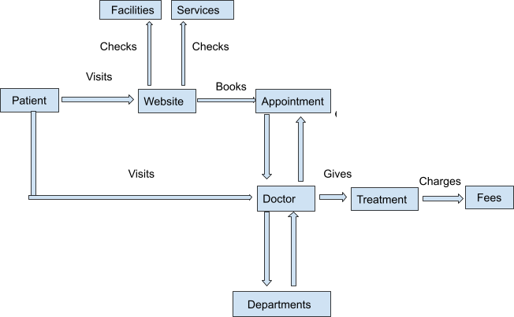

**SITE MAP**

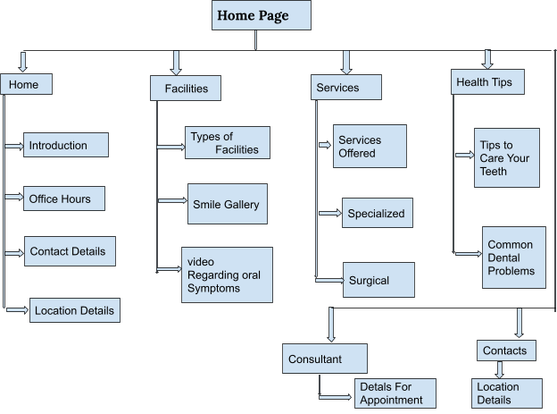

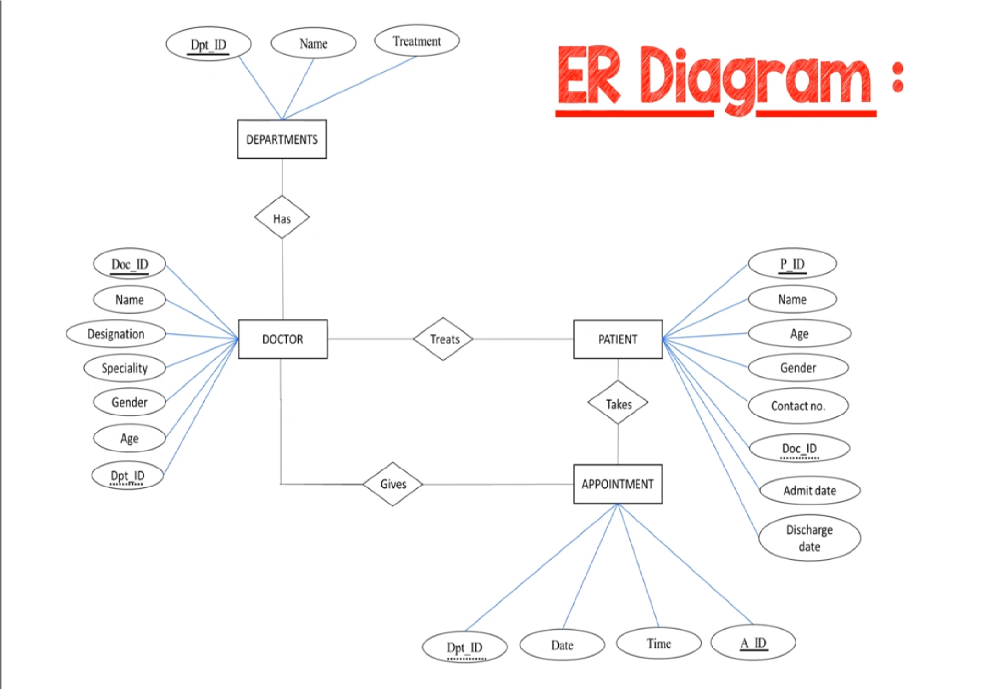

**Screen Shots:-**

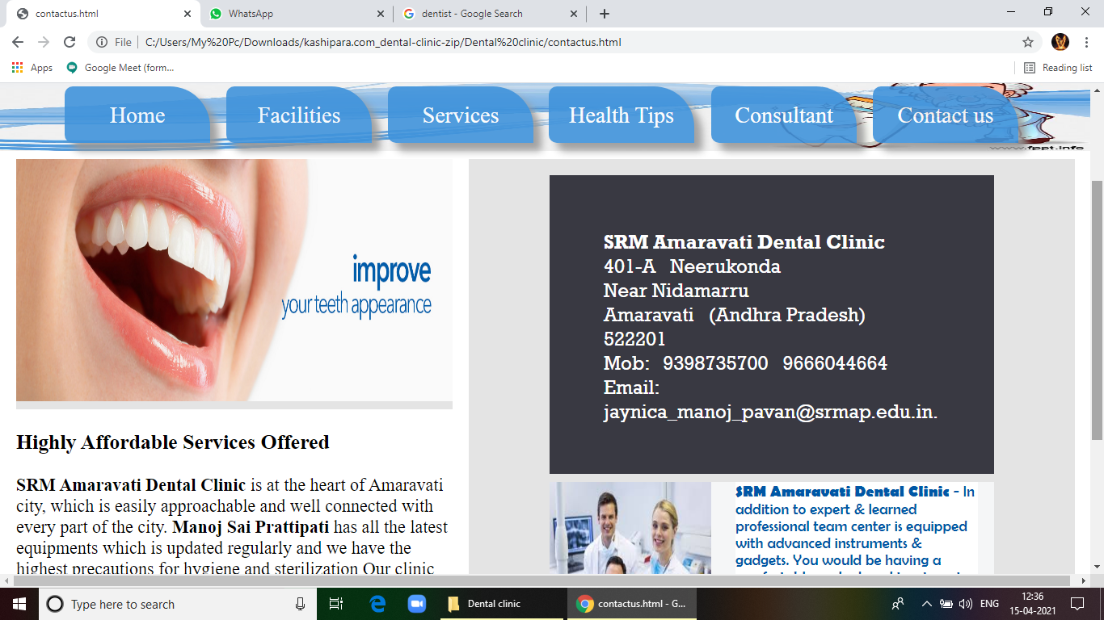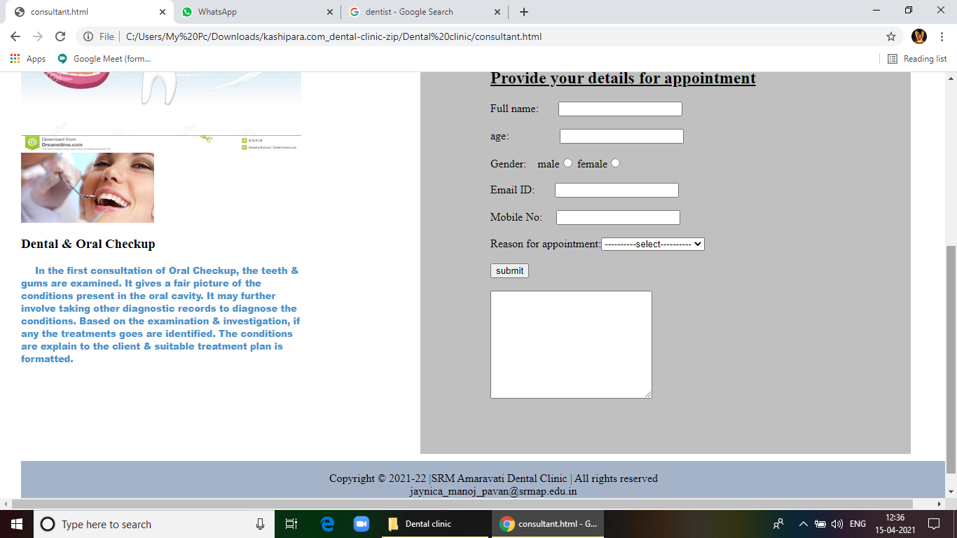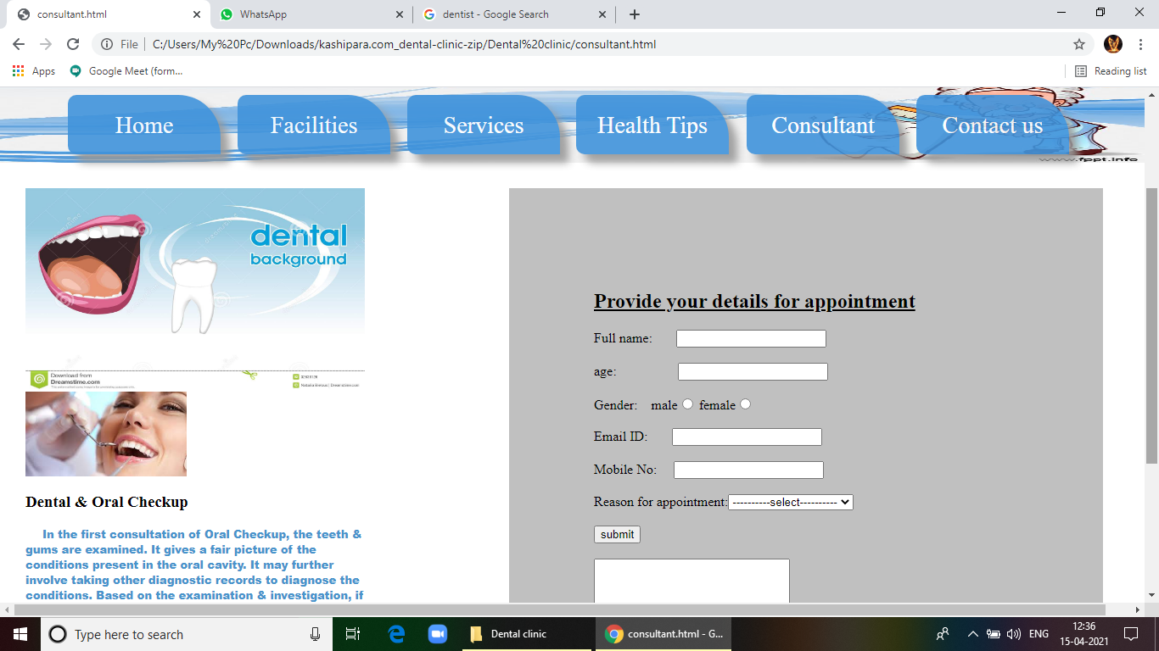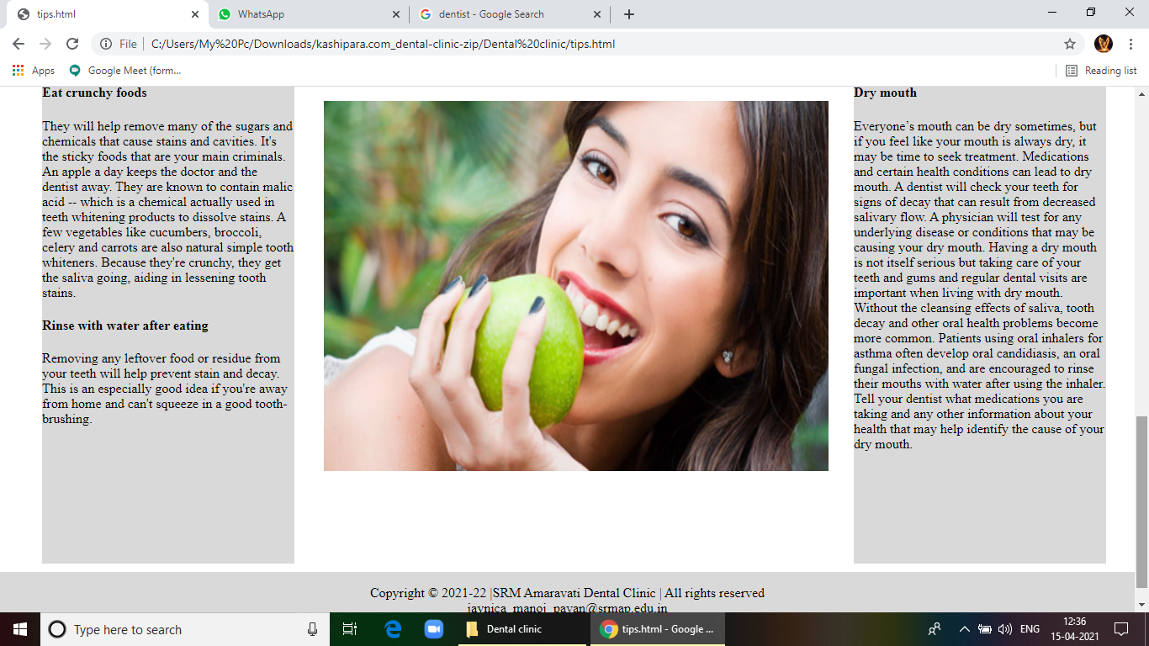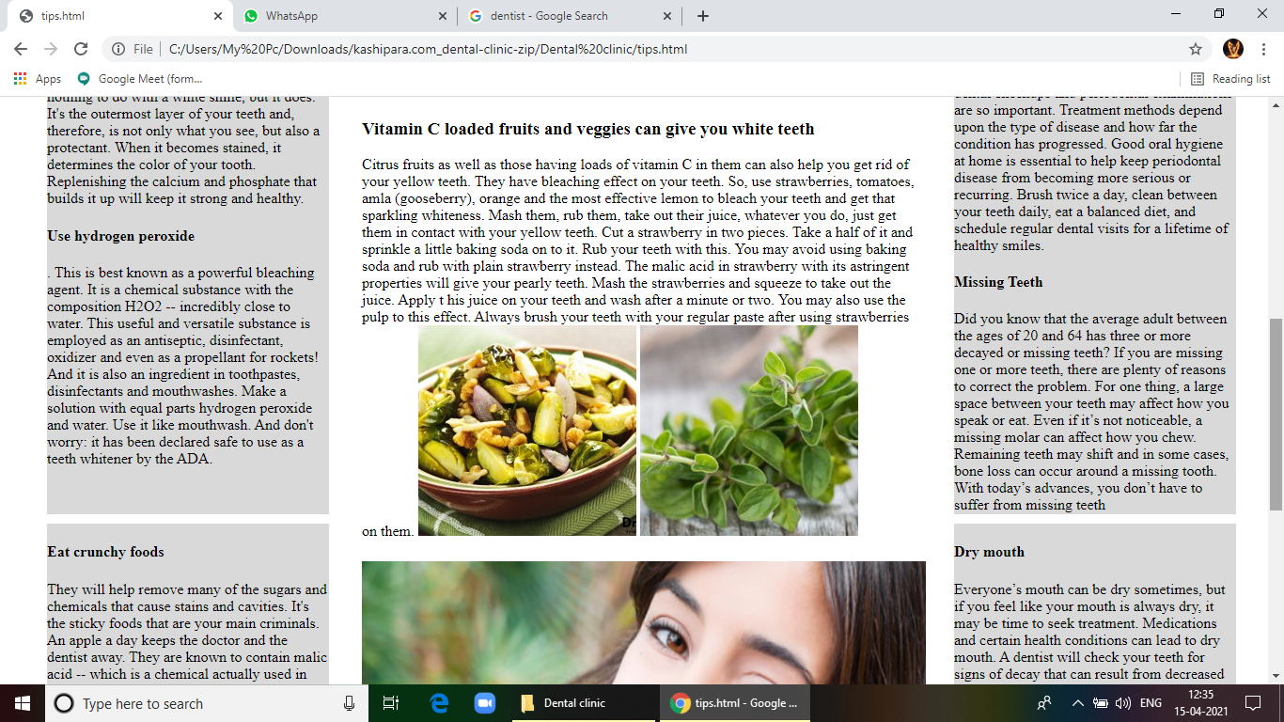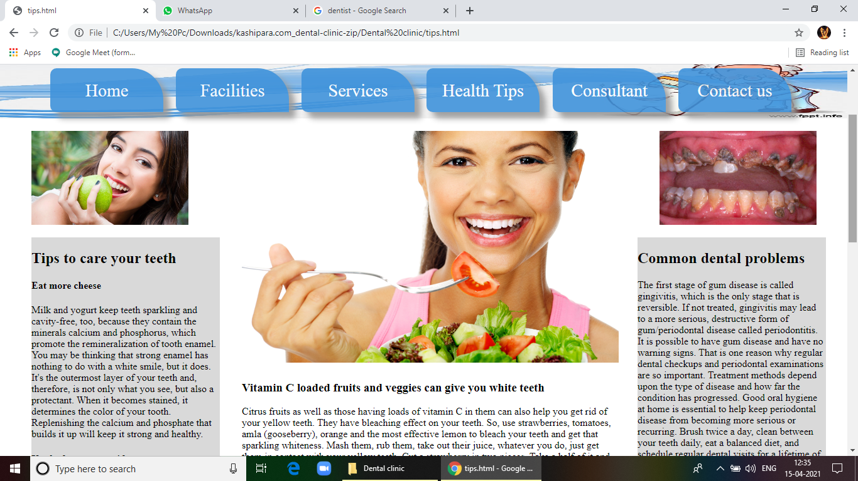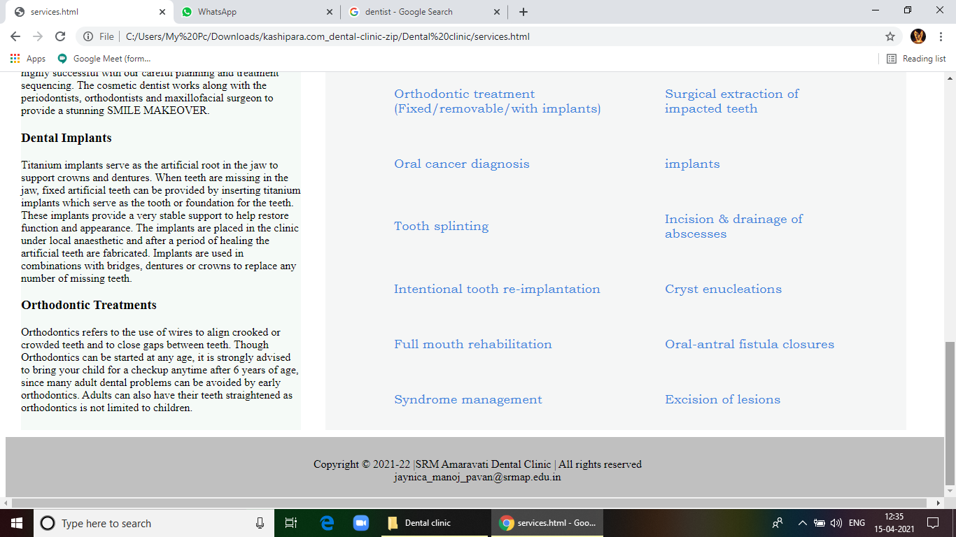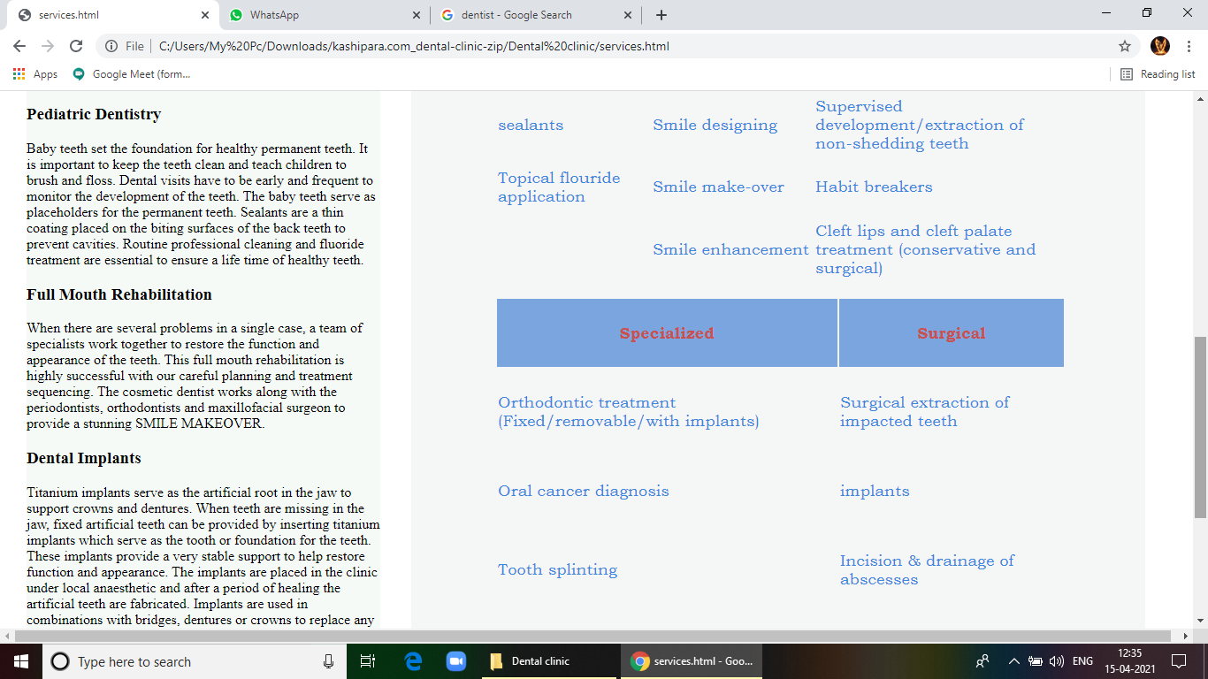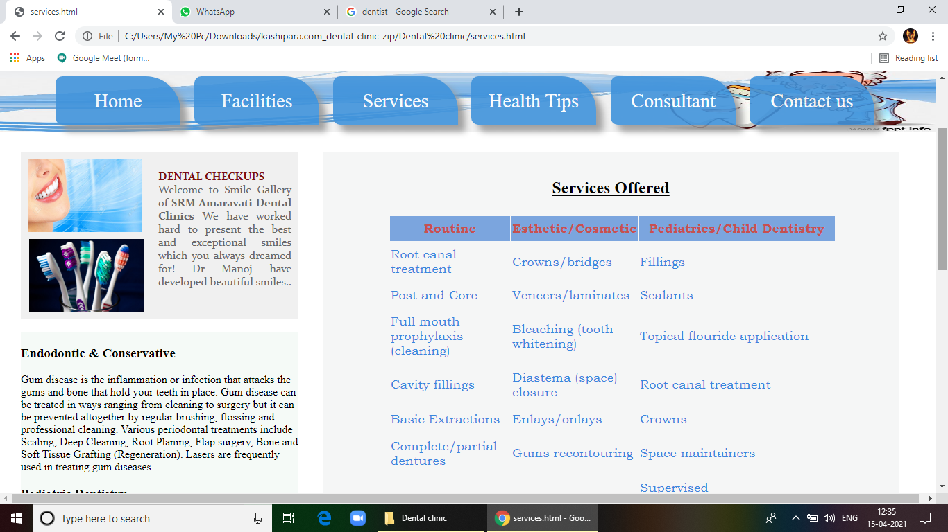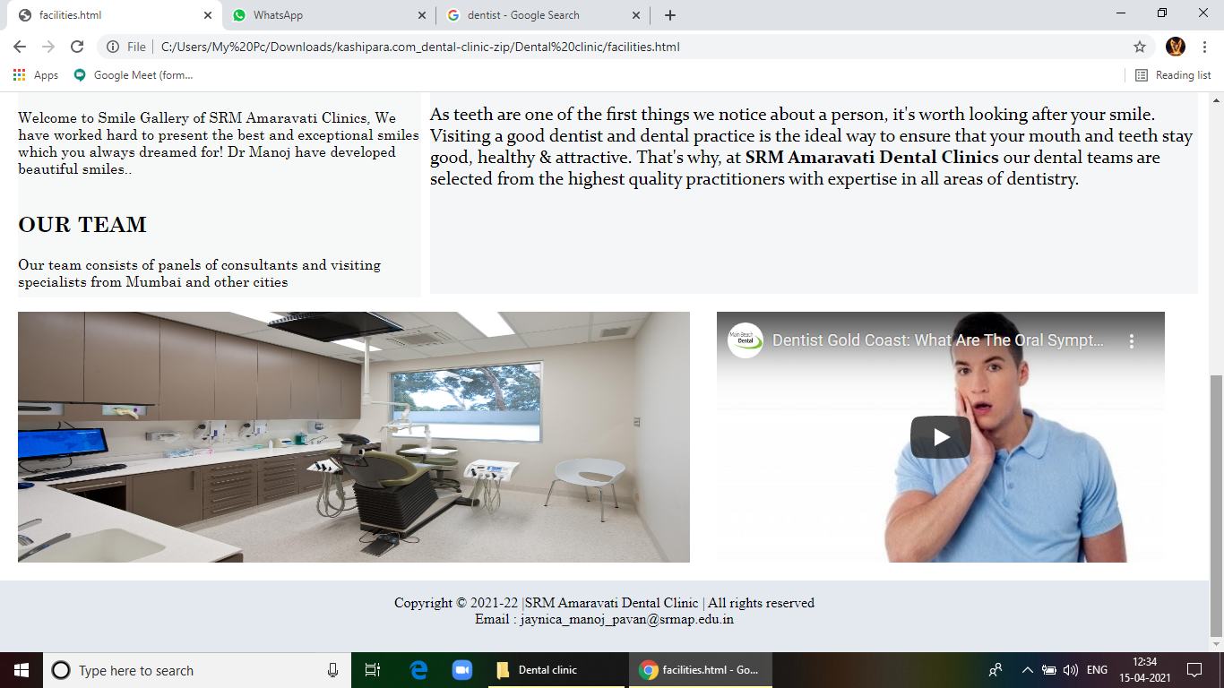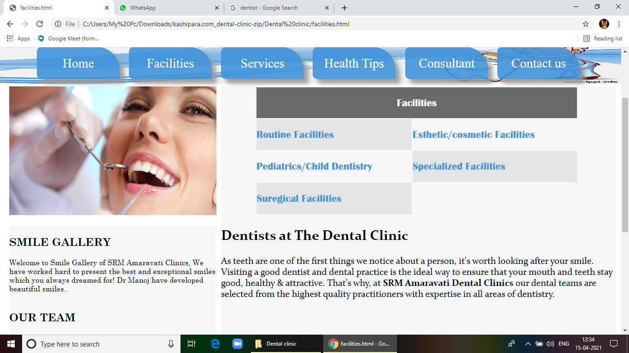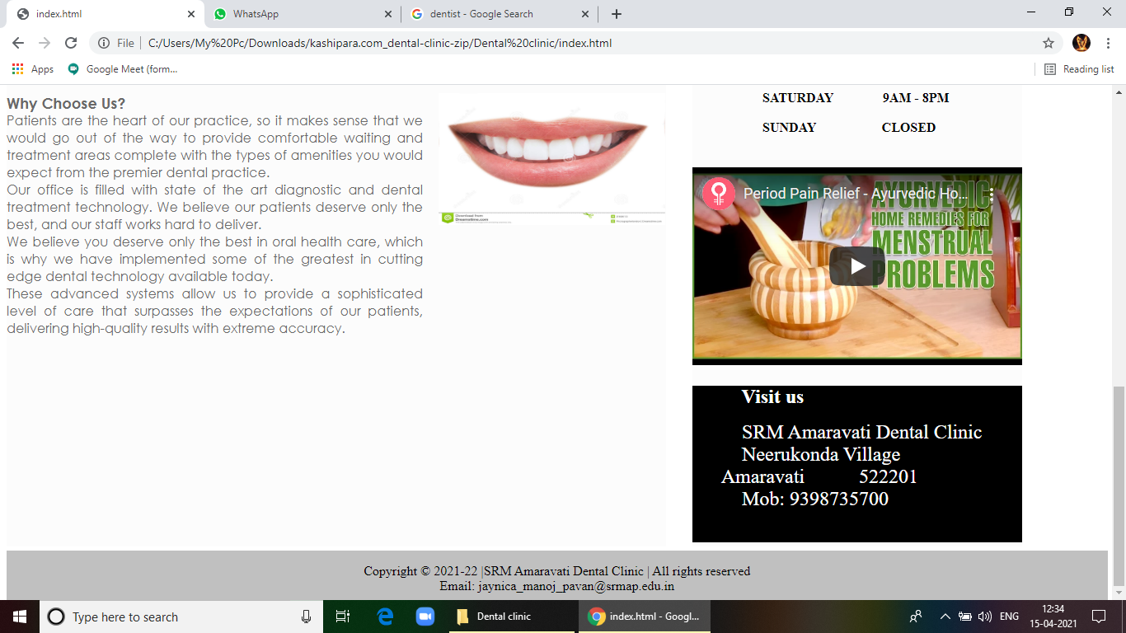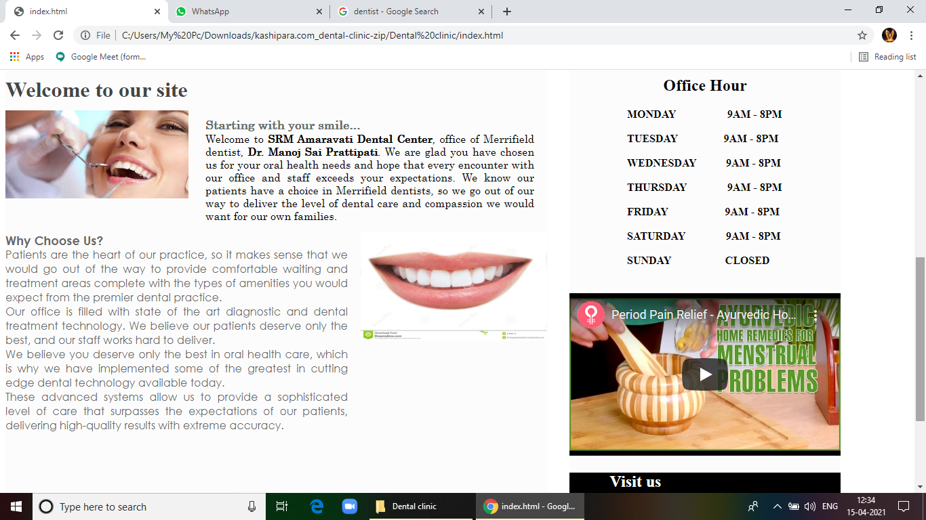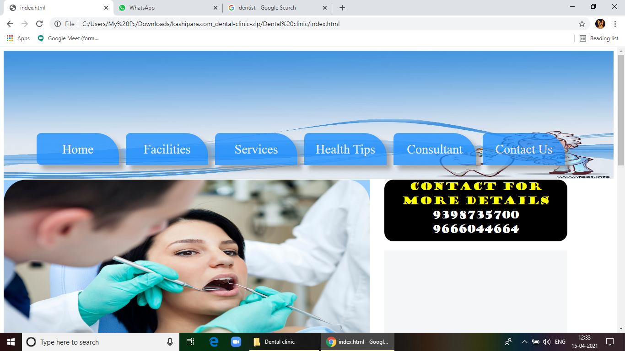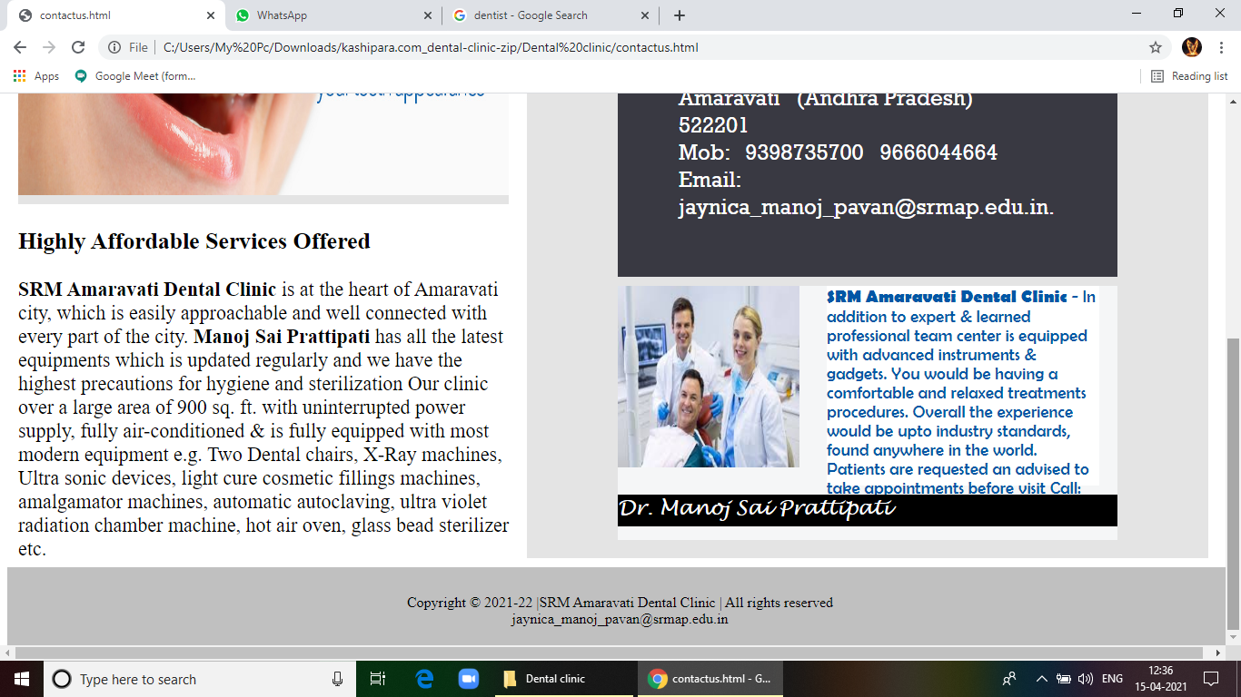

**References / Bibliography:-**

1. <HTTP://WWW.AIIMS.EDU/EN.HTML>
2. <HTTP://DELHI.GOV.IN/WPS/WCM/CONNECT/DOIT_DDUH/HOME>
3. HTTP://WWW.MEDANTA.ORG

**Conclusion;-**

1. Earlier the records were kept done manually which was highly time-consuming and expensive.
2. The can be no interaction between the patients and doctors.
3. Patients used to stand in long queues.
4. Wastage of stationary other material resources increases due to paperwork.
5. The current manual system requires large efforts to compile information.
6. With the increase in data, the processes of maintaining, updating, and storing information are becoming difficult.
7. Data extraction becomes difficult as one has to search among a large pile of papers.
8. This system helps in lowering manual work done by the patients to get appointments of doctors in a single click. It helps in keeping the patients updated about the availability of doctors.
9. Nowadays, it has become easy to get information through websites.No newspaper, magazines, and interviews, etc. are required because every information is easily available on the website.
10. It helps in reaching the information to a large number of patients/visitors in minimum time. Modes of information are faster than the way before.
11. It can be a centralized source of information.